CSA 283: Exam Two

Name: ______________________________________ Section: _____ _____

Please write legibly. Ask questions if something is unclear. Write down any assumptions you make.

- List the two transport layer protocols commonly used in the Internet. (4 points)

_________________

_________________

- Write the network layer protocol used by the Internet. (2 points)

_________________

- Considering your answers to the previous two questions, which of the protocols provides reliable connection oriented service? (2 points)

_________________

- Give definitions for the following terms using one or two sentences. If the term is an acronym, also state what the letters in the acronym stand for and give a definition. (6 points)

a. Sample RTT:

b. Inter-AS Routing Protocol

c. Tunneling:

- A block of data for transmission using the TCP protocol has been broken up for transmission into four separate segments. The sequence number of the first segment is 200.The first segment contains 50 bytes, the second segment contains 20 bytes the third segment contains 50 bytes, and the fourth segment contains 60 bytes. Write the correct sequence number for each segment and the sequence number that would be used by the receiver to indicate in order receipt of each segment. (8 points)

 | Segment Sequence Number | Acknowledgement Number
First Segment
Second Segment
Third Segment
Fourth Segment

- Assume the second and third segments are lost in the previous question:

    - What will be the acknowledgement sent by the receiver when it receives the fourth segment? (3 points)

    - Under a Go-Back-N protocol, what will the receiver do with this fourth packet? (3 points)

    - Under Selective-Repeat, what will the receiver do with this fourth packet? (3 points)

- List the four pieces of information used to identify a TCP socket connection. (4 points)

_________________

_________________

_________________

_________________

How does this information make TCP different from UDP? (Tell me how TCP uses the information) (3 points)

- Host A has calculated the congestion window to be 10,000 bytes. The receive window for Host B to which the host A is sending data is 8,000 bytes. Host A has transmitted 9,000 bytes of data. 6,000 of these bytes have been acknowledged. What is the maximum number of bytes Host A can transmit to Host B at this time? Explain/show your reasoning. (4 points)

- In the previous question, is flow control or congestion control limiting the size of the transmission window of host A? (Circle one.) (2 points)

Flow Control Congestion Control

- The following group of IP fragments has been received:

 | Length =  1460 | ID = 22 | Fragflag = 1 | Offset =  0

 | Length =  1460 | ID = 22 | Fragflag = 1 | Offset = 180

 | Length =  1460 | ID = 22 | Fragflag = 1 | Offset = 540

 | Length =  400 | ID = 19 | Fragflag = 0 | Offset = 180

 | Length =  560 | ID = 22 | Fragflag = 0 | Offset = 900

    - Are all the fragments from the same segment? If not, how many segments. (3 points)

    - Has all the data been received? If not, give the missing ranges of bytes for each of the original segments involved? (6 points)
- TCP flow control uses the number of duplicate acks and timeouts to determine the transmission rate. Assume following events:

- transmission of data begins at time 0 (RTT 0) with a congestion window size of 1 MSS (Maximum Segment Size).
- three duplicates acks received between RTT 3 and RTT 4.
- timeout event occurs between at RTT 6 and RTT 7.
- positive acks received during all other RTT intervals

Write the size of the congestion window and the threshold for each RTT period in terms of MSS. The CongWin should be adjusted at the end of each RTT interval based on what happens in the interval. (8 points)

Time | Size of congestion Window (CongWin) in Maximum Segment Sizes (MSS) | Threshold in MSS
0 RTT | 1 | ∞
1 RTT
2 RTT
3 RTT
4 RTT
5 RTT
6 RTT
7 RTT
8 RTT

- Below is a portion of a routing table.

Prefix | Link Interface
11001011 00010111 00010 | 0
11001011 00010111 00011000 | 1
11001011 00010111 00011 | 2
Otherwise | 3

    - Give the Classless InterDomain Routing (CIDR) notation for the subnets identified by the first two rows of the table (for example 200.23.16.0/23). Indicate approximately how many hosts each sub-net could contain.
(6 points)

CIDR notation Approx. Number of Hosts

________________________ __________

________________________ __________

    - Using the destination IP addresses, determine which link interface each of the following packets should be sent to. (6 points)

Destination IP Address | Link Interface
11001011 00010111 0001110 00011000
11001011 00010111 00011000 11101110
11001000 00010111 00010110 10101101

- Using node A in Figure 1 as the source, use the link state (LV) algorithm to find the shortest path to all other nodes. Show the members of N, the predecessor of each destination, and the shortest known distance to each destination after the initialization phase of the algorithm and after each main loop iteration. (6 points)
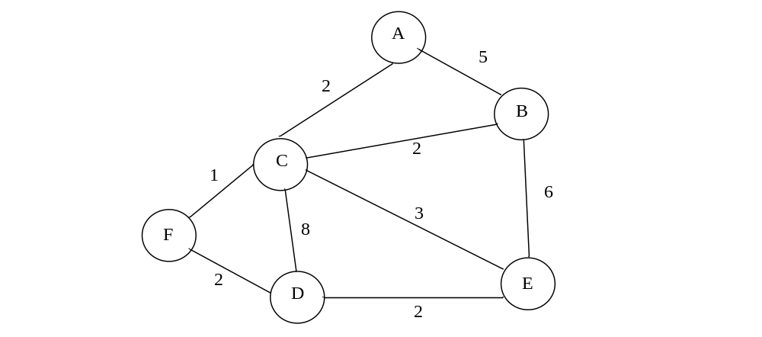
Figure 1: Network Graph

- Figure 2 is a simple network diagram. The network includes three hosts (A, B, and C) and one router. The router is performing Network Address Translation (NAT) using the NAT table below the figure. An application on host B using port 4500 sends a datagram containing an HTTP request to an application running on a host, Z, in the internet with an IP address of 137.76.29.5 and a port number of 80.
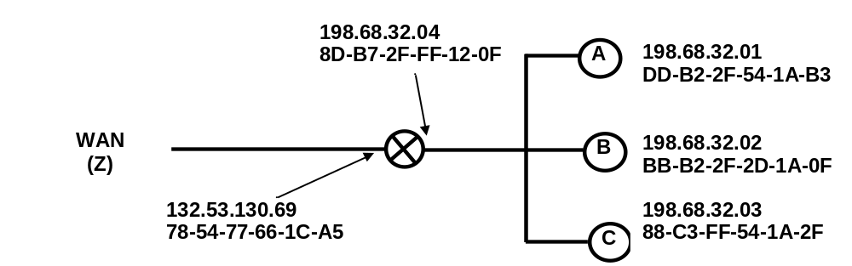
Figure 2: Simple Network with a Router Using the NAT Protocol
NAT Translation Table
WAN side address | LAN side address
132.53.130.69, 4500 | 198.68.32.01, 4505
132.53.130.69, 3250 | 198.68.32.02, 4505
132.53.130.69, 2200 | 198.68.32.02, 4500
… | …
Fill in the source and destination IP addresses and port numbers that will be carried in datagrams at the following four points in the network.
(8 points)

 | Outgoing |  |  | Incoming
 | From B to router | From router to Z | From Z to router |  | From router to B
Source IP
Source Port
Dest. IP
Dest. Port

- Sequence numbers are used by the TCP protocol to detect duplicate packets.
(2 points)

TRUE FALSE

- Fast retransmit occurs after a timeout occurs in order to avoid an extended delay before resending a lost packet. (2 points)

TRUE FALSE

- TCP uses network assistance for congestion control. (2 points)

TRUE FALSE

- Under TCP, if retransmissions are rare, the timeout interval is recalculated about once every round trip time (RTT).(2 points)

TRUE FALSE

- The TCP protocol uses a three way handshake to establish a connection.
(2 points)

TRUE FALSE

- Information used to build the forwarding table of an interior router is supplied by either an inter-AS algorithm or an intra-AS routing algorithm, but not both.
(2 points)

TRUE FALSE

- A networked device can use the ARP protocol to automatically obtain an IP address in a “plug-and-play” manner. (2 points)

TRUE FALSE

- When using TCP, an application can guarantee both a minimum bandwidth and .a maximum delay. (2 points)

TRUE FALSE

- IP addresses are normally used by the transport layer for multiplexing and demultiplexing. (2 points)

TRUE FALSE
1 Initialization:
2 N = {A}
3 for all nodes v
4 if v adjacent to A
5 then Dist(v) = cost(A,v)
6 else Dist(v) = infinity
7
8 Loop
9 find w not in N such that Dist(w) is a minimum
10 add w to N
11 update Dist(v) for all v adjacent to w and not in N:
12 Dist(v) = min( Dist(v), Dist(w) + cost(w,v) )
13 /* new cost to v is either old cost to v or known
14 shortest path cost to w plus cost from w to v */
15 until all nodes in N

1 Initialization:
2 for all destinations y in N
3 D_{x}(y) = cost(x,y) // infinity if y not a neighbor
4 for each neighbor w
5 D_{w}(y) = infinity
6 for each neighbor w
7 send distance vector D_{x} = [D_{x}(y): y in N]
8 Loop
9 wait (till adjacent link cost changes or distance
vector is received from a neighbor)
10 for all destinations y in N
11 D_{x}(y) = min_{v}{cost(x,v) + D_{v}(y) }
12 if D_{x}(y) change for any destination y
13 send distance vector D_{x} = [D_{x}(y): y in N] to all neighbors
14 forever

